NS-QSFP28-CWDM4-10

100Gb/s 10km QSFP28 Transceiver Hot Pluggable, CWDM4 Duplex LC Connector, Single mode

Features:
- 4 lanes MUX/DEMUX design
- Integrated CWDM TOSA / ROSA for up to 10km reach over SMF
- Support 100GBASE-CWDM4 for line rate of 103.125Gbps and OTU4 for line rate of 111.81Gbps
- Aggregate bandwidth of > 100Gbps
- Duplex LC connectors
- Compliant with IEEE 802.3-2012 Clause 88 standard IEEE 802.3bm CAUI-4 chip to module electrical standard ITU-T G.959.1-2012-02 standard
- Single +3.3V power supply operating
- Built-in digital diagnostic functions
- Temperature range 0°C to 70°C
- RoHS Compliant Part

Applications:

- Local Area Network (LAN)
- Wide Area Network (WAN)
- Ethernet switches and router applications

Description:
The NS-QSFP28-CWDM4-10 is a transceiver module designed for 10km optical communication applications. The design is compliant to 100GbASE-LR4 of the IEEE 802.3-2012 Clause 88 standard IEEE 802.3bm CAUI-4 chip to module electrical standard ITU-T G.959.1-2012-02 standard . The module converts 4 inputs channels (ch) of 25.78 Gbps to 27.95Gbps electrical data to 4 lanes optical signals, and multiplexes them into a single channel for 100Gb/s optical transmission. Reversely, on the receiver side, the module optically de-multiplexes a 100Gb/s input into 4 lanes signals, and converts them to 4 lanes output electrical data.
The central wavelengths of the 4 lanes are 1270 nm, 1290 nm, 1310 nm and 1330 nm . It contains a duplex LC connector for the optical interface and a 38-pin connector for the electrical interface. To minimize the optical dispersion in the long-haul system, single-mode fiber (SMF) has to be applied in this module.
The product is designed with form factor, optical/electrical connection and digital diagnostic interface according to the QSFP28 Multi-Source Agreement (MSA). It has been designed to meet the harshest external operating conditions including temperature, humidity and EMI interference.
The module operates from a single +3.3V power supply and LVCMOS/LVTTL global control signals
such as Module Present, Reset, Interrupt and Low Power Mode are available with the modules. A 2-wire serial interface is available to send and receive more complex control signals and to obtain digital diagnostic information. Individual channels can be addressed and unused channels can be shut down for maximum design flexibility.
The NS-QSFP28-CWDM4-10 is designed with form factor, optical/electrical connection and digital diagnostic interface according to the QSFP28 Multi-Source Agreement (MSA). It has been designed to meet the harshest external operating conditions including temperature, humidity and EMI interference. The module offers very high functionality and feature integration, accessible via a two-wire serial interface.

Absolute Maximum Ratings

Parameter | Symbol | Min. | Typical | Max. | Unit
Storage Temperature | T_{S} | -40 |  | +85 | °C
Supply Voltage | V_{CC}T, R | -0.5 |  | 4 | V
Relative Humidity | RH | 0 |  | 85 | %
- Recommended Operating Environment:

Parameter | Symbol | Min. | Typical | Max. | Unit
Case operating Temperature | T_{C} | 0 |  | +70 | °C
Supply Voltage | VCCT, R | +3.13 | 3.3 | +3.47 | V
Supply Current | ICC |  | 1100 | 1500 | mA
Power Dissipation | PD |  |  | 5 | W
- Electrical Characteristics (T_{OP} = 0 to 70 °C, VCC = 3.13 to 3.47 Volts

Parameter | Symbol | Min | Typ |  | Max |  | Unit | Note
Data Rate per Channel |  | - | 25.78125 |  |  |  | Gbps
 |  |  | 27.9525
Power Consumption |  | - | 2.7 |  | 3.5 |  | W
Supply Current | Icc |  | 0.8 |  | 1 |  | A
Control I/O Voltage-High | VIH | 2.0 |  |  | Vcc |  | V
Control I/O Voltage-Low | VIL | 0 |  |  | 0.7 |  | V
Inter-Channel Skew | TSK |  |  |  | 35 |  | Ps
RESETL Duration |  |  | 10 |  |  |  | Us
RESETL De-assert time |  |  |  |  | 100 |  | ms
Power On Time |  |  |  |  | 100 |  | ms
Transmitter
Single Ended Output Voltage  Tolerance |  | 0.3 |  | Vcc |  | V |  | 1
Common mode Voltage Tolerance |  | 15 |  |  |  | mV

Transmit Input Diff Voltage | VI | 150 |  | 1200 | mV
Transmit Input Diff Impedance | ZIN | 85 | 100 | 115
Data Dependent Input Jitter | DDJ |  | 0.3 |  | UI
Receiver
Single Ended Output Voltage  Tolerance |  | 0.3 |  | 4 | V
Rx Output Diff Voltage | Vo | 370 | 600 | 950 | mV
Rx Output Rise and Fall Voltage | Tr/Tf |  |  | 35 | ps | 1
Total Jitter | TJ |  | 0.3 |  | UI
Note:
1. 20～80%

Optical Parameters(TOP = 0 to 70 °C, VCC = 3.0 to 3.6 Volts)

Parameter | Symbol | Min | Typ | Max |  | Unit |  | Ref.
Transmitter
Wavelength Assignment | L0 | 1264.5 | 1271 |  | 1277.5 |  | nm
 | L1 | 1284.5 | 1291 |  | 1297.5 |  | nm
 | L2 | 1304.5 | 1311 |  | 1317.5 |  | nm
 | L3 | 1324.5 | 1331 |  | 1337.5 |  | nm
Side-mode Suppression Ratio | SMSR | 30 | - |  | - |  | dB
Total Average Launch Power | PT | -4.5 | - |  | 6.5 |  | dBm
Average Launch Power, each Lane |  | -4.5 | - |  | 2.5 |  | dBm
Difference in Launch Power between  any two Lanes (OMA) |  | - | - |  | 3.5 |  | dB
TDP, each Lane | TDP |  |  |  | 2.2 |  | dB
Extinction Ratio | ER | 4 | - |  | - |  | dB
Transmitter Eye Mask Definition {X1, X2, X3, Y1, Y2, Y3} |  | {0.25, 0.4,  0.45,  0.25,  0.28, 0.4}
Optical Return Loss Tolerance |  | - | - |  | 20 |  | dB
Average Launch Power OFF  Transmitter, each Lane | Poff |  |  |  | -30 |  | dBm
Relative Intensity Noise | Rin |  |  |  | -128 |  | dB/H  Z | 1
Optical Return Loss Tolerance |  | - | - |  | 12 |  | dB
Receiver
Damage Threshold | THd | 3.3 |  |  |  | dBm |  | 1
Average Power at Receiver Input, each | R | -11 |  | 0 |  | dBm
Lane
RSSI Accuracy |  | -2 |  | 2 |  | dB
Receiver Reflectance | Rrx |  |  | -26 |  | dB
Receiver Power (OMA), each Lane |  | - | - | 3.5 |  | dBm
LOS De-Assert | LOSD |  |  | -15 |  | dBm
LOS Assert | LOSA | -25 |  |  |  | dBm
LOS Hysteresis | LOSH | 0.5 |  |  |  | dB
Note
  - 12dB Reflection

Diagnostic Monitoring Interface
Digital diagnostics monitoring function is available on all QSFP28 IR4. A 2-wire serial interface provides user to contact with module. The structure of the memory is shown in flowing. The memory space is arranged into a lower, single page, address space of 128 bytes and multiple upper address space pages. This structure permits timely access to addresses in the lower page, such as Interrupt Flags and Monitors. Less time critical time entries, such as serial ID information and threshold settings, are available with the Page Select function. The interface address used is A0xh and is mainly used for time critical data like interrupt handling in order to enable a one-time-read for all data related to an interrupt situation. After an interrupt, IntL has been asserted, the host can read out the flag field to determine the affected channel and type of flag.
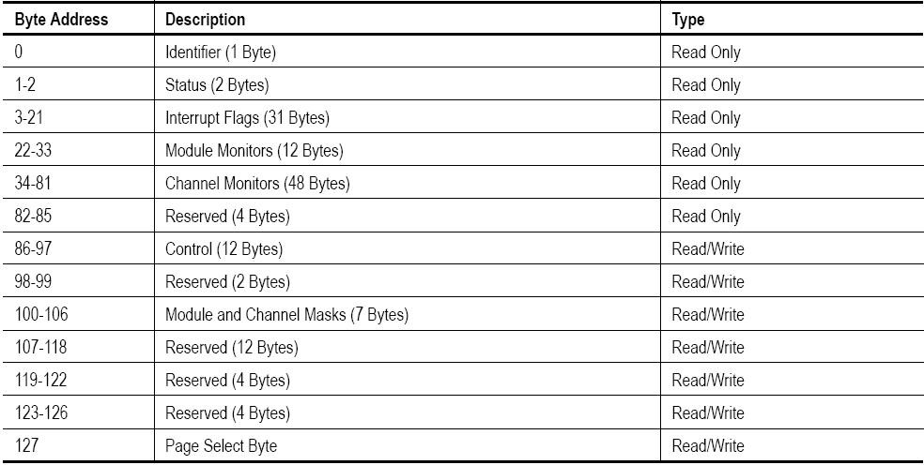
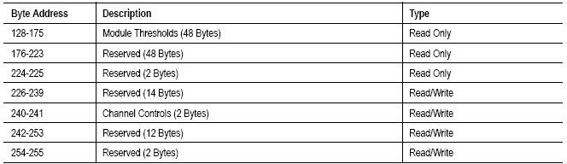

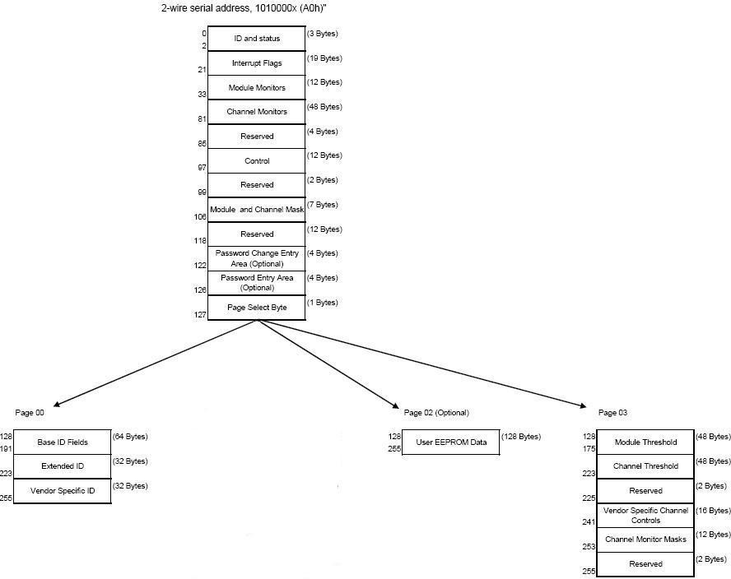

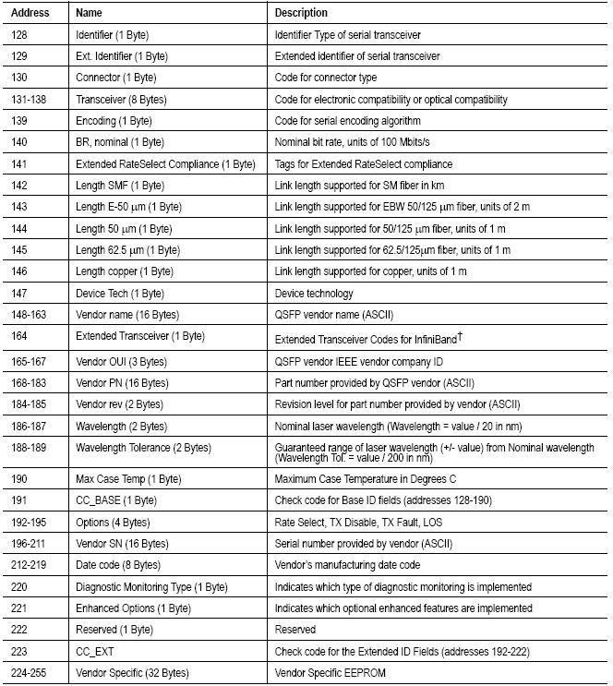

Page02 is User EEPROM and its format decided by user.
The detail description of low memory and page00.page03 upper memory please see SFF-8436 document.

Timing for Soft Control and Status Functions

Parameter | Symbol | Max | Unit | Conditions
Initialization Time | t_init | 2000 | ms | Time from power on1, hot plug or rising edge of Reset until the module is fully  functional2
Reset Init Assert Time | t_reset_init | 2 | μs | A Reset is generated by a low level longer than the minimum reset pulse time present  on the ResetL pin.
Serial Bus Hardware Ready Time | t_serial | 2000 | ms | Time from power on1 until module responds to data transmission over the 2-wire serial  bus
Monitor Data Ready  Time | t_data | 2000 | ms | Time from power on1 to data not ready, bit  0 of Byte 2, deasserted and IntL asserted
Reset Assert Time | t_reset | 2000 | ms | Time from rising edge on the ResetL pin until  the module is fully functional2
LPMode Assert Time | ton_LPMode | 100 | μs | Time from assertion of LPMode  (Vin:LPMode =Vih) until module power consumption enters lower Power Level
IntL Assert Time | ton_IntL | 200 | ms | Time from occurrence of condition  triggering IntL until Vout:IntL = Vol
IntL Deassert Time | toff_IntL | 500 | μs | toff_IntL 500 μs Time from clear on read3 operation of associated flag until Vout:IntL = Voh. This includes deassert times for Rx LOS,  Tx Fault and other flag bits.
Rx LOS Assert Time | ton_los | 100 | ms | Time from Rx LOS state to Rx LOS bit set and  IntL asserted
Flag Assert Time | ton_flag | 200 | ms | Time from occurrence of condition triggering flag to associated flag bit set and  IntL asserted
Mask Assert Time | ton_mask | 100 | ms | Time from mask bit set4 until associated IntL  assertion is inhibited
Mask De-assert Time | toff_mask | 100 | ms | Time from mask bit cleared4 until associated  IntlL operation resumes
ModSelL Assert Time | ton_ModSel L | 100 | μs | Time from assertion of ModSelL until  module responds to data transmission over the 2-wire serial bus
ModSelL Deassert Time | toff_ModSel L | 100 | μs | Time from deassertion of ModSelL until the module does not respond to data  transmission over the 2-wire serial bus
Power_over-ride or Power-set Assert Time | ton_Pdown | 100 | ms | Time from P_Down bit set 4 until module power consumption enters lower Power  Level
Power_over-ride or Power-set De-assert  Time | toff_Pdown | 300 | ms | Time from P_Down bit cleared4 until the module is fully functional3
Note：
- Power on is defined as the instant when supply voltages reach and remain at or above the minimum specified value.
- Fully functional is defined as IntL asserted due to data not ready bit, bit 0 byte 2 de-asserted.
- Measured from falling clock edge after stop bit of read transaction.
- Measured from falling clock edge after stop bit of write transaction.

Transceiver Block Diagram
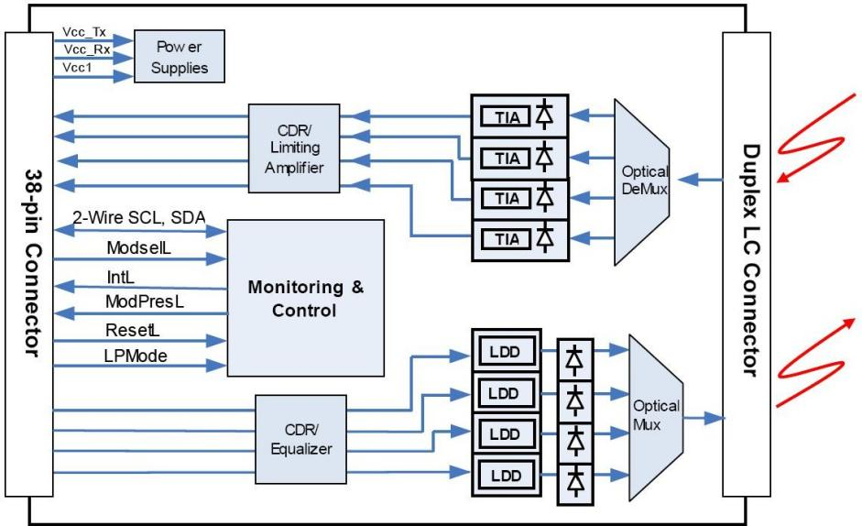
- Pin Assignment
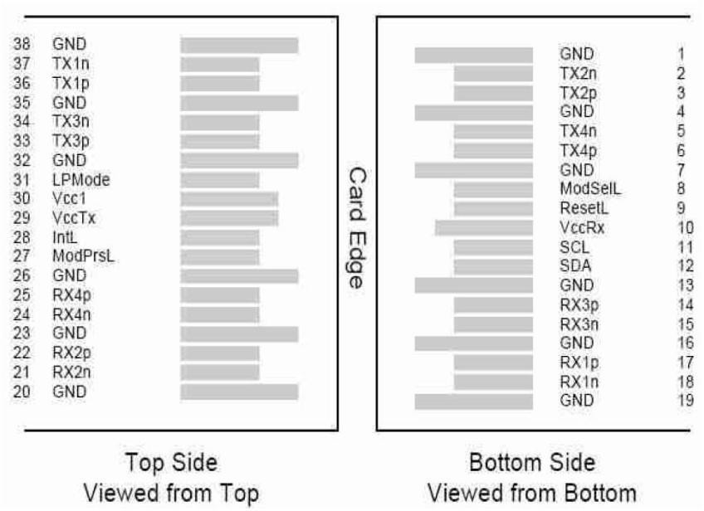
Diagram of Host Board Connector Block Pin Numbers and Name

Pin Description

Pin | Logic | Symbol | Name/Description | Ref.
1 |  | GND | Ground | 1
2 | CML-I | Tx2n | Transmitter Inverted Data Input
3 | CML-I | Tx2p | Transmitter Non-Inverted Data output
4 |  | GND | Ground | 1
5 | CML-I | Tx4n | Transmitter Inverted Data Output
6 | CML-I | Tx4p | Transmitter Non-Inverted Data Output
7 |  | GND | Ground | 1
8 | LVTTL-I | ModSelL | Module Select
9 | LVTTL-I | ResetL | Module Reset
10 |  | VccRx | +3.3V Power Supply Receiver | 2
11 | LVCMOS-I/O | SCL | 2-Wire Serial Interface Clock
12 | LVCMOS-I/O | SDA | 2-Wire Serial Interface Data
13 |  | GND | Ground | 1
14 | CML-O | Rx3p | Receiver Inverted Data Output
15 | CML-O | Rx3n | Receiver Non-Inverted Data Output
16 |  | GND | Ground | 1
17 | CML-O | Rx1p | Receiver Inverted Data Output
18 | CML-O | Rx1n | Receiver Non-Inverted Data Output
19 |  | GND | Ground | 1
20 |  | GND | Ground | 1
21 | CML-O | Rx2n | Receiver Inverted Data Output
22 | CML-O | Rx2p | Receiver Non-Inverted Data Output
23 |  | GND | Ground | 1
24 | CML-O | Rx4n | Receiver Inverted Data Output
25 | CML-O | Rx4p | Receiver Non-Inverted Data Output
26 |  | GND | Ground | 1
27 | LVTTL-O | ModPrsL | Module Present
28 | LVTTL-O | IntL | Interrupt
29 |  | VccTx | +3.3V Power Supply Transmitter | 2
30 |  | Vcc1 | +3.3V Power Supply | 2
31 | LVTTL-I | LPMode | Low Power Mode
32 |  | GND | Ground | 1
33 | CML-I | Tx3p | Transmitter Inverted Data Output
34 | CML-I | Tx3n | Transmitter Non-Inverted Data Output
35 |  | GND | Ground | 1
36 | CML-I | Tx1p | Transmitter Inverted Data Output
37 | CML-I | Tx1n | Transmitter Non-Inverted Data Output
38 |  | GND | Ground | 1
Notes:
  - GND is the symbol for single and supply(power) common for QSFP28 modules, All are common within the QSFP28 module and all module voltages are referenced to this potential otherwise noted. Connect these directly to the host board signal common ground plane. Laser output disabled on TDIS >2.0V or open, enabled on TDIS <0.8V.
  - VccRx, Vcc1 and VccTx are the receiver and transmitter power suppliers and shall be applied concurrently. Recommended host board power supply filtering is shown below. VccRx, Vcc1 and VccTx may be internally connected within the QSFP28 transceiver module in any combination. The connector pins are each rated for maximum current of 500mA.

Recommended Circuit

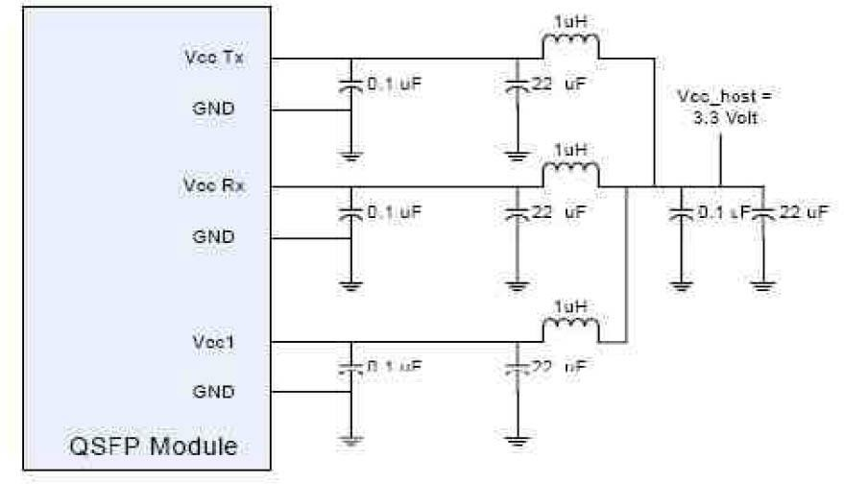

- Mechanical Dimensions
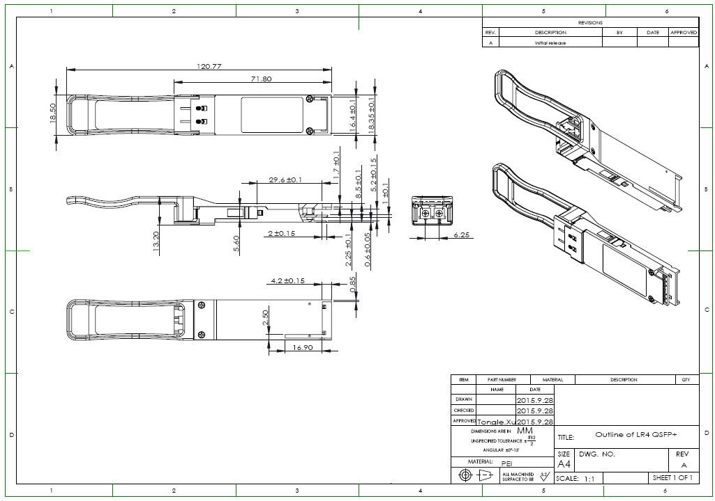

NetsGroup reserves the right to make changes to the products or information contained herein without notice. No liability is assumed as a result of their use or application. No rights under any patent accompany the sale of any such products or information.

